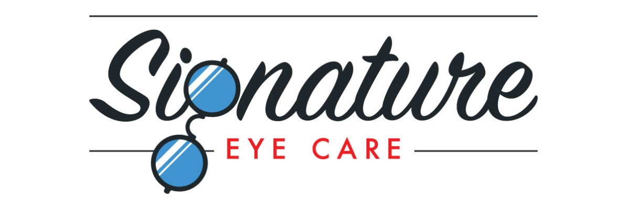
Media Release Form
I grant permission to Signature Eye Care to use my image (photographs and/or video) for use in Signature Eye Care publications including videos, newsletters, and magazines and to use my image in electronic versions of the same publications or on the Signature Eye Care website or other electronic forms of media, including social media. I hereby waive any right to inspect or approve the finished photographs or electronic matter that may be used in conjunction with them now or in the future, whether that use is known to me or unknown, and I waive any right to royalties or other compensation arising from or related to the use of the image.
Please check the paragraph below which is applicable to your present situation:
_____I am 18 years of age or older and I am competent to contract in my own name. I have read this release before signing below, and I fully understand the contents, meaning and impact of this release. I understand that I am free to address any specific questions regarding this release by submitting those questions in writing prior to signing, and I agree that my failure to do so will be interpreted as a free and knowledgeable acceptance of the terms of this release.
_____I am the parent or legal guardian of the below named child. I have read this release before signing below, and I fully understand the contents, meaning and impact of this release. I understand that I am free to address any specific questions regarding this release by submitting those questions in writing prior to signing, and I agree that my failure to do so will be interpreted as a free and knowledgeable acceptance of the terms of this release.
Date: ____________
Name (please print):_______________________________________________________
Address: ________________________________________________________________
Signature: _______________________________________________________________
Signature of parent or legal guardian (if under 18 years of age):____________________

