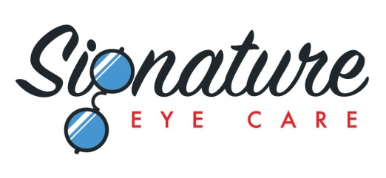
OPTOMAP AND DILATION FORM
Signature Eye Care strives to offer the best possible standard of care for our patients and this is why we offer state-of-the-art digital scanning technology to image the inside of your eye – The Optomap.
Advantages of the Optomap Exam
- NO blurred vision
- NO light sensitivity
- Images takes less than one minute
- See your own retina in the most comprehensive way
- Images are saved to your chart as a great baseline for future exams
Dr. Lou, Dr. Chu, Dr. Dollar and Dr. Bolen recommend that ALL patients of ALL ages have a thorough retinal examination every year to detect and diagnose eye diseases. The Optomap is their preferred method over dilation. This non-invasive procedure allows a much broader and more detailed view of the retina and replaces the need for dilation. Diseases such as macular degeneration, glaucoma, retinal detachments, diabetic retinopathy, tumors and other vision threatening conditions can be missed without an examination of the retina. There is an additional fee of only $39 for the Optomap procedure (covers both eyes) as this service is generally not covered by insurance companies.

I have been informed of the importance of having a comprehensive retinal eye examination annually in the detection and diagnosis of eye disease and vision threatening conditions. I understand that I can have my retinas examined by either the Optomap procedure or by having my eyes dilated.
( ) I elect to have the Optomap procedure at an additional fee of only $39.
( ) I elect to have dilation.
( ) I would like to discuss further with the technician before making a decision.
( ) I am declining the Doctors’ recommendation to obtain a comprehensive view of my retinas. By foregoing both the Optomap and dilation procedures I do not hold Signature Eye Care, Dr. Oliver Lou, Dr. Nick Chu, Dr. Eric Dollar, or Dr. Carrie Bolen responsible for my retinal and eye health.
*************PLEASE HOLD ON TO THIS SHEET AND TURN IN TO YOUR TECHNICIAN**************
*************PLEASE FILL OUT BOTH SIDES OF THIS SHEET**************

